Steps:
I have configured build step for
- “Execute HP tests using HP Performance Center”
- Post run action “collate and analyze”
- Post build Action Publish HP tests Results
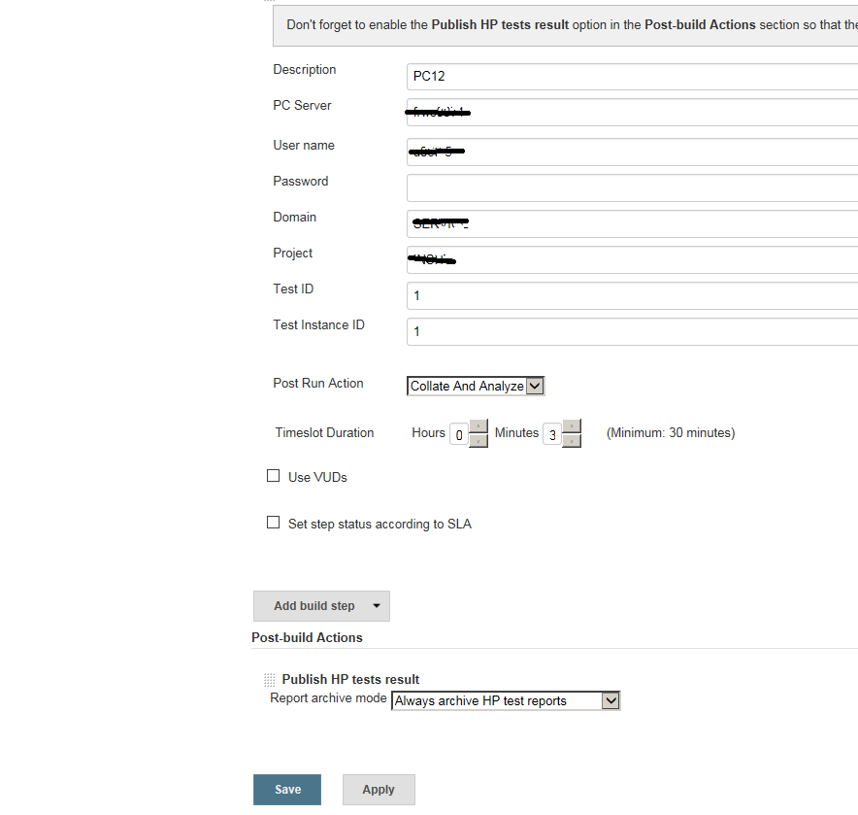

As soon I start build,
What I am seeing,
- Test gets kicked off and end with “success”

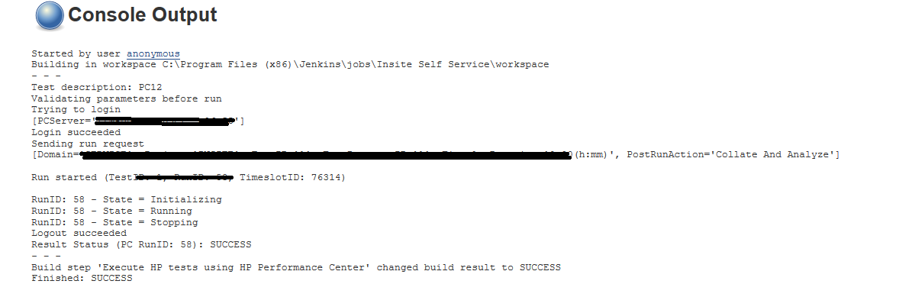

- but in console I do not see “collate and analyze” once test stopped
- and also I do not see HTML test report.

